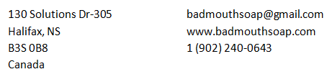
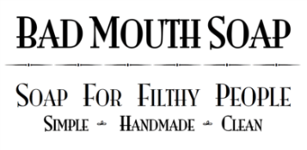

NEW WHOLESALE ACCOUNT APPLICATION

- Legal Company Name: _____________________________________________________
- Type of merchandise sold: __________________________________________________
- Date established: _________________________________________________________
- Company shipping address: _________________________________________________
- Company billing address: ___________________________________________________
- Company website (if applicable): _____________________________________________
- Company Facebook, Twitter, Instagram (if applicable): ___________________________ ________________________________________________________________________
- Email address: ____________________________________________________________
- Federal Tax Identification number: ___________________________________________
- Amount of soap would you like to order? ______________________________________
- Minimum in the amount of $400CAN): ________________________________________
- Which soaps are you interested in carrying? ___________________________________
_________________________________________________________________________________________________________________________________________________________________________________________________________________________________

By signing this application, the president or company owner states that all information is true. Any false information will result in account termination. You also agree that if upon approval, all BAD MOUTH SOAPs will be sold in this establishment at retail price ($7.00 CDN)

If approved, please allow up to 6 weeks to fulfill order. All orders are made at time of approval, and soap takes up to 3 weeks to fully cure.

X______________________________________________ __________________
Signature Date

_______________________________________________
Print Name

